AI -Based Diabetes Prediction System

**Phase – 3**

We started building our project by loading the dataset, performing text preprocessing, and conducting analysis in Jupyter Notebook.

**Loading the Dataset:**

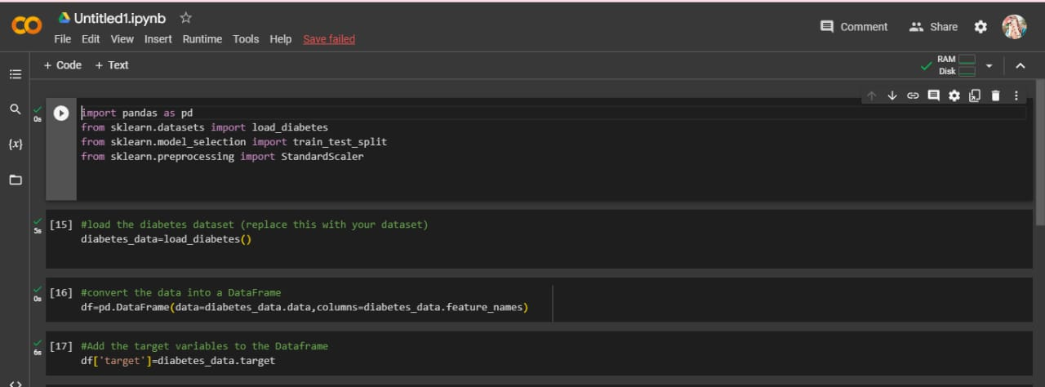The first step in building the diabetes prediction system is to load the dataset. Typically, the dataset will be in a file format such as CSV. In Jupyter Notebook, you can use pandas library to load the dataset into a Dataframe

Text Preprocessing:

Data preprocessing for diabetes prediction system includes cleaning and transforming the raw dataset, handling missing values and outliers, scaling and normalizing the features, and splitting the data into training and testing sets.

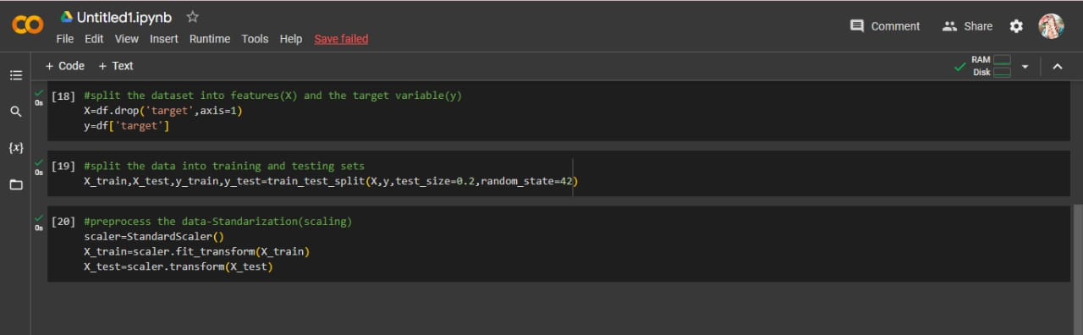

**Using Natural Language ToolKit Library for Text Preprocessing**

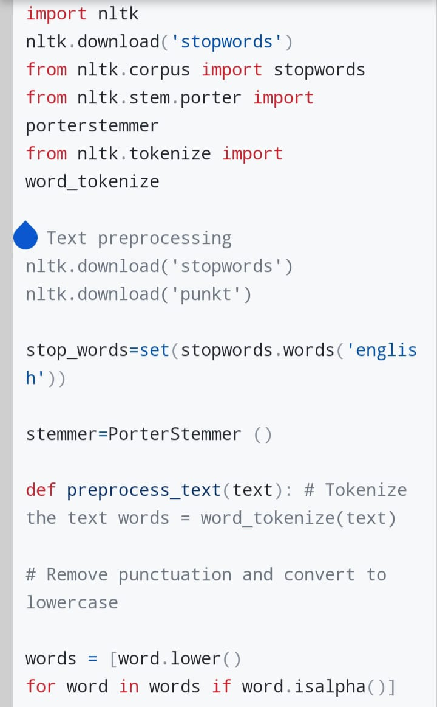Next, you need to perform text preprocessing on the dataset to clean and transform the textual data. This involves tasks such as removing punctuation, converting text to lowercase, removing stop words, and stemming/lemmatizing the words

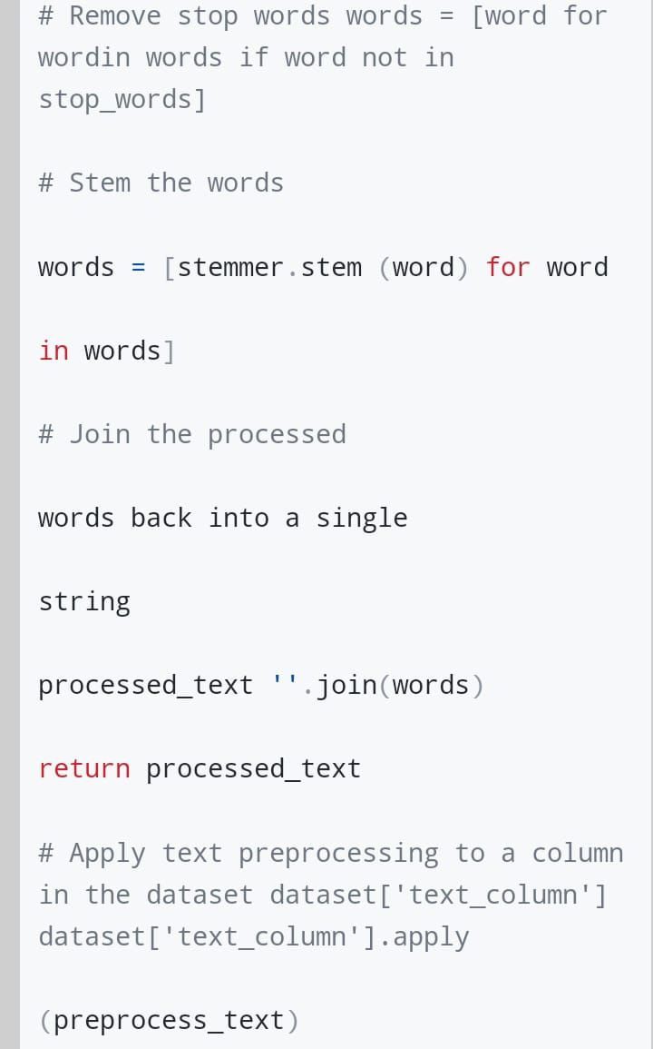

Team members:

A.Apshana

M. Amina shafrin

U.mydeen fathima

I. Nilofer nisha

S. Sankarammal